### A

Report On

“Design of Flywheel”

Submitted By

**Mr. Amit Dadasaheb Pawar (PRN No.:- 71924303D)**

(Department of Mechanical Engineering)



# Department of Mechanical Engineering

**D.Y. Patil College of Engineering, Akurdi,**

**Pune-411 044**

**[2020-21]**

## ABSTRACT

A flywheel is the heavy rotating mass which is placed between the power source and the driven machine to act as a reservoir of energy. It is used to store the energy when the demand of energy of energy is less and deliver it when the demand of energy is high. The current paper is focused on the analytical design of arm type of flywheel which is used for punching press operation. Now in regard to the design of flywheel it is required to decide the mean diameter of the flywheel rim, which depends upon two factors such as availability of space and the limiting value of peripheral velocity of the fly wheel. However the current design problem is formulated for punching machine which has to be make holes of 30 holes/minute in a steel plate of 18mm thickness with space limitation that is the diameter of flywheel should not exceed 1000mm, hence it can be observed that the design of the flywheel is to be carried out (based) on the availability of space limitation and accordingly the fluctuation of energy, dimensions of the flywheel, stresses induced in the flywheel are determined. Finally after detail analysis it is observed that the induced diameter of the flywheel is less than the allowable/permissible diameter and hence it can be concluded that the design is safe from availability of space point of view.

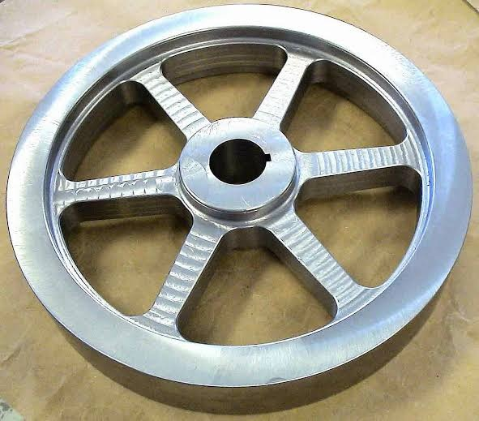

## INTRODUCTION

One of the major advantages of flywheels is the ability to handle high power levels. This is a desirable quality in e.g. a vehicle, where a large peak power is necessary during acceleration and, if electrical breaks are used, a large amount of power is generated for a short while when breaking, which implies a more efficient use of energy, resulting in lower fuel consumption.

In regard to the design of flywheel it is required to decide the mean diameter of the flywheel rim, which depends upon two factors such as availability of space and the limiting value of peripheral velocity of the fly wheel. However the current design problem is formulated for punching machine which has to be make holes of 30 holes/minute in a steel plate of 18mm thickness with space limitation that is the diameter of flywheel should not exceed 1000mm, hence it can be observed that the design of the flywheel is to be carried out (based) on the availability of space limitation.

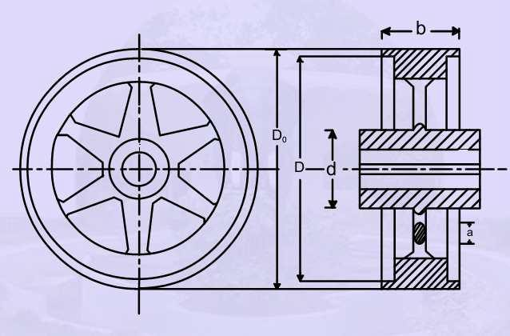

Arm Type of Flywheel

## Literature Survey

The early models where purely mechanical consisting of only a stone wheel attached to an axle. Nowadays flywheels are complex constructions where energy is stored mechanically and transferred to and from the flywheel by an integrated motor/generator. The stone wheel has been replaced by a steel or composite. Rotor and magnetic bearings have been introduced. Today flywheels are used as supplementary UPS storage at several industries world over. Future applications span a wide range including electric vehicles, intermediate storage for renewable energy generation and direct grid applications from power quality issues to offering an alternative to strengthening transmission. One of the key issues for viable flywheel construction is a high overall efficiency, hence a reduction of the total losses. By increasing the voltage, current losses are decreased and otherwise necessary transformer steps become redundant. So far flywheels over 10kV have not been constructed, mainly due to isolation problems associated with high voltage, but also because of limitations in the power electronics. Recent progress in semi-conductor technology enables faster switching and lower costs. The predominant part of prior studies has been directed towards optimizing mechanical issues whereas the electro technical part now seems to show great potential for improvement. An overview of flywheel technology and previous projects are presented and moreover a 200kW flywheel using high voltage technology is simulated.

Sudipta Saha, Abhik Bose, G. Sai Tejesh, S.P. Srikanth(2013)

The performance of a flywheel can be attributed to three factors, i.e., material strength, geometry (cross-section) and rotational speed. While material strength directly determines kinetic energy level that could be produced safely combined (coupled) with rotor speed, this study solely focuses on exploring the effects of flywheel geometry on its energy storage/deliver capability per unit mass, further defined as Specific Energy. Proposed Computer aided analysis and optimization procedure results show that smart design of flywheel geometry could both have a significant effect on the Specific Energy performance and reduce the operational loads exerted on the Shaft/bearings due to reduced mass at high rotational speeds. This paper specifically studies the most common five different geometries (i.e., straight/concave or convex shaped2D).

M.lavakumar, R .prasanna srinivas (2013)

This paper involves the design and analysis of flywheel to minimize the fluctuation in torque, the flywheel is subjected to a constant rpm. The objective of present work is to design and optimize the flywheel for the best material. The flywheel is modelled with solid 95 (3-D element), the modelled analyses using free mesh. The FEM mesh is refined subject to convergence criteria. Preconditioned conjugate gradient method is adopted during the solution and for deflections. Von-misses stress for both materials (mild steel and mild steel alloy) are compared, the best material is suggested for manufacture of flywheel.

Sushama G Bawane , A. P. Ninawe and S. K. Choudhary(2012)

By using optimization technique various parameter like material, cost for flywheel can be optimized and by applying an approach for modification of various working parameter like efficiency, output, energy storing capacity, we can compare the result with existing flywheel result. Based on the dynamic functions, specifications of the system the main features of the flywheel are initially determined; the detail design study of flywheel is done. Then FEA ANALYSIS for more and more designs in diverse areas of engineering is being analyzed through the software. FEA provides the ability to analyze the stresses and displacements of a part or assembly, as well as the reaction forces other elements are to impose. This thesis guides the path through flywheel design, and analysis the material selection process. The FEA model is described to achieve a better understanding of the mesh type, mesh size and boundary conditions applied to complete an effective FEA model. At last the design objective could be simply to minimize cost of flywheel by reducing material.

## Problem Statement

The design of arm type flywheel is to be carried out for punching press machine with the consideration of space requirement or with the condition that the diameter of flywheel should not exceed than 1000mm. The fly wheel is to design which is used to punch 30 holes

/ minute on a steel plate of 18 mm thickness. In concern this geometrical dimension, material, and function values of flywheel as stated below:

Geometrical Dimensions and material condition:

* Flywheel should not exceed the diameter of 1000mm
* Coefficient of fluctuation of speed :0.1
* Mean speed of flywheel : 270 rpm
* Mass of flywheel : 254 kg
* Material of flywheel : Grey cast iron with density
* 7100kg/m3

Functional values of flywheel:

The following table shows the details about flywheel design parameters

Flywheel - Arm type

Total Energy (N-M) - 3592.6 Fluctuation of energy (N-M) - 3233.3 Rim velocity (m/s) - 11.3

## Solution

Let us determine the various parameters in regard with flywheel design.

* Mean speed of flywheel N= 9 Number of strokes/min

=9×30

=270rpm

* Maximum shear stress required to punch a hole

=Shear strength ×resisting area

=fs× π dt

=240× π×25×18 / 1000

=339.3kN

* Energy required to punch one hole

=average force × distance travelled by punch

=0.5×339.3× 18

=3053.7N

Since mechanical efficiency is less than 100%, assuming as 85% ,therefore Total energy required, E=3053.7/0.85

=3592.6N-m

Actual punching operation lasts for the 1/10th of the cycle period. Therefore, during remaining period 9/10th of the cycle period, the energy is stored by the flywheel.

* Thus fluctuation of energy =9/10× E= 3233.3Nm

Maximum space available is 100mm, therefore considering as D=800mm to carry out design

* Rim Velocity= (π× 0.8×270) / 60

=11.3m/s

which is less than the maximum permissible velocity for grey cast iron

* Mass of flywheel, m= (fluctuation of energy) / ( V2 × Cs)

= 3233.3 / 11.32×0.1

= 253.3 Kg

Assuming mass of rim as 90%of total mass,

* mrim =0.9×253.2=227.88Kg
* mrim= πDhp

used to determine dimensions of rim Where, p=7100kg/m3for C.I

.

Therefore, h=90mm, b=150mm

* Outer diameter of flywheel=Do=D+h=0.89m

which is less than the maximum space of 1m, hence the design dimensions are within limit.

To determine Shaft diameter

* Bending moment M =weight of flywheel× overhang

=253.2×9.81× 0.2=496.78N-m

* Average torque = (Energy required/min) / 2πN

= 107778 / 2π×270

=63.53N-m

Assuming suddenly applied load condition with shock and fatigue factor of 1.5 and 2

* Equivalent torque =((Cm×M)2 +(Ct× T)2)1/2

=755.92N-m

Shaft is made of medium carbon steel, with shear strength 360N-mm2, Factor of safety is 4, therefore shaft diameter can be determined by using torsion equation

* Shaft diameter,ds =34.96 say=40mm
* Hub diameter, dh= 2ds=80mm
* Length of hub, lh = 2.5 ds=100mm

To determine the Stresses in the rim of flywheel

* Stresses in unstrained rim = pv2

= 7100×11.32

=0.9066MN/m2

* Stresses in restrained rim = pv2(2πR2/ i2h)

=4.97 MN/m2

* Total Stress in the rim ,

= 0.75 Stresses in unstrained rim+0.25 Stresses in restrained rim

=1.922 MN/m2

which is less than the allowable strength of C.I, hence design of rim is safe

To determine stress in arm of flywheel Considering arm type flywheel of four arms Bending stress in the arm =10N/mm2

=T(D-dh) / iDz Where, Z=modulus of elasticity=1429.4mm3

i=numbers of arms=4

* Direct stress due to centrifugal force =pv2=0.9066N/mm2
* Total stress = Bending stress+ Direct stress

=10+0.9066=10.9066N/mm2

Total stress is less than the allowable strength 20N/mm2, hence the design of the arms are safe.

**Applications of flywheel**

1.providing continous source of energy when the energy source is discontinuous

2.dynamic balancing of rotating elements

3.energy storage in small scale electricity generator sets

4.delivering energy at rates beyond the ability of a continous energy source.

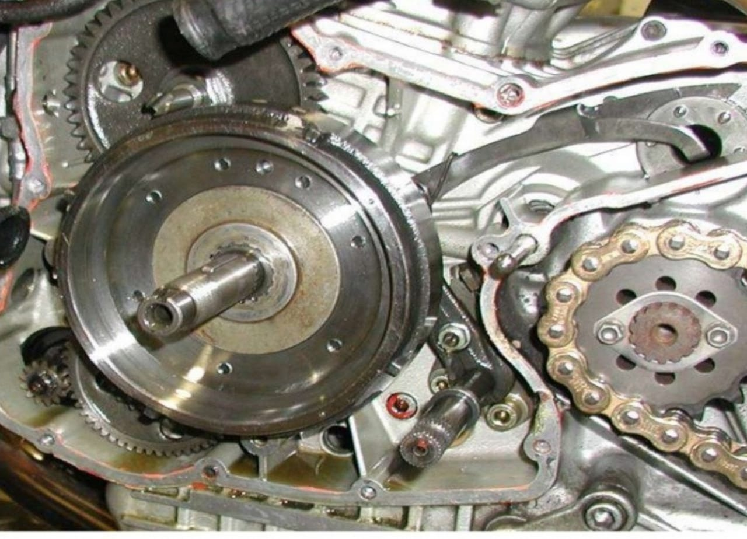

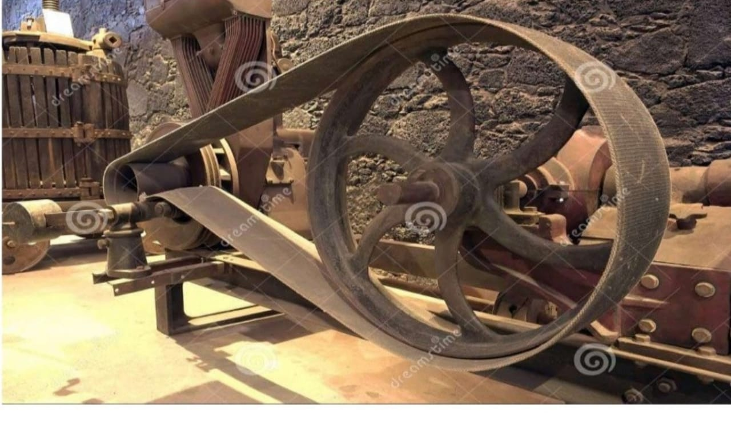

## References

1. Akshay P. Punde, G.K.Gattani , Analysis of Flywheel, International Journal of Modern Engineering Research (IJMER) , Vol.3, Issue.2, March-April. 2013 pp-1097-1099
2. Bjorn Bolund , Hans Bernhoff, Mats Leijon , Flywheel energy and power storage systems, international journal of Renewable and Sustainable Energy Reviews 11 (2007) 235–258
3. Sudipta Saha, Abhik Bose, G. Sai Tejesh, S.P. Srikanth , computer aided design & analysis on flywheel for greater efficiency, International Journal of Advanced Engineering Research and Studies, IJAERS/Vol. I/ Issue II/January-March, 2012/299- 301
4. M.lavakumar, R.prasanna srinivas, Design and analysis of light weight motor vehicle flywheel, International Journal of Computer Trends and Technology (IJCTT) – volume 4 Issue -7July 2013
5. Sushama G Bawane , A P Ninawe and S K Choudhary, Analysis and optimization of flywheel, International Journal of mechanical engineering and robotics Vol. 1, No. 2, July 2012